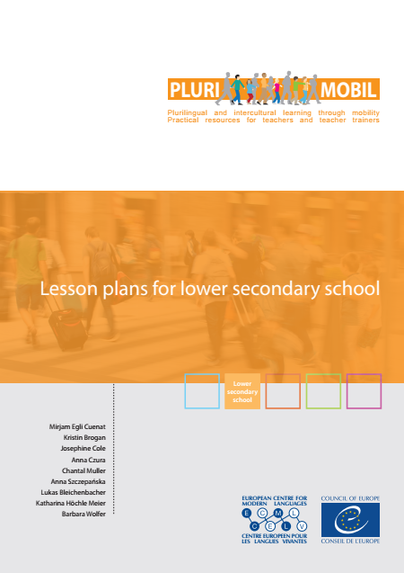

**PluriMobil**

**Lesson plans for lower secondary school**

Table of contents

Introduction to PluriMobil lesson plans 2

Lesson plan 1 The visible, the less visible, the invisible 4

Lesson plan 2 Different views on culture(s) 8

Lesson plan 3 My self-portrait 11

Lesson plan 4 My Autobiography of Intercultural Encounters 18

Lesson plan 5 My topic of Interest in the other culture 23

Lesson plan 6 Presentation 28

Lesson plan 7 Treasures from abroad 31

Lesson plan 8 Appetite for culture 33

Lesson Plan 9 The European Language Portfolio: How do I learn and how do I want to learn? 35

Lesson plan 10 The European Language Portfolio: What do I use to learn? 42

Lesson plan 11 My Learning Diary 45

Lesson plan 12 Language hungry! 47

Lesson plan 13 Planning a mobility project as a host 52

This set of lesson plans belongs to the **PluriMobil** projecthttp://plurimobil.ecml.at

Please quote the source if you integrate all or parts of these lesson plans into your own projects.

# Introduction to PluriMobil lesson plans

These lesson plans are part of the concept explained in the *PluriMobil* *Handbook* and the *PluriMobil quick start guide* available on the PluriMobil website.

The term “lesson plan” can mean *one* period of teaching of e.g. 45 or 60 minutes that can take place before, during and after the mobility activity, but it can also mean *several periods* of teaching. It is not necessary to use all the lesson plans – the teachers are free to select the lesson plans that best match the type of mobility project and address their learners’ needs. The detailed organisation of the activity and the timing are up to the teacher.

# 1. Structure of the lesson plans

In the lesson plans, you will find the following rubrics:

* A box: a short summary that informs about the content of the lesson plan
* Experiences: the kind of experiences the learner can gain with the suggested activities
* Targeted competences: a list of linguistic, intercultural, personal etc. competences which learners can achieve during the activities
* Suggestions for procedure: description of possible content and development of the activity, separated into the different phases of the mobility project (before – during – after)
* Suggestions for the final product for the portfolio
* Tools and resources: this section refers to pedagogical instruments developed by the Council of Europe such as the *European Language Portfolio* (ELP) or the *Autobiography of Intercultural Encounters* (AIE) as well as other sources such as websites, books, pictures etc.
* Examples: this section refers to ready-made worksheets or possible examples supporting the suggested activities

# 2. Use of the lesson plans

We would like to point to the following issues:

* **Description of procedure**: all the activities described in the lesson plans are *suggestions* that you can adapt to your own context and needs.
* **Flexible order**: all lesson plans can be used in a *variable order*; you do not have to use one lesson plan after the other. The choice depends on your needs and context (type of mobility activity, age of learners, available resources, etc.).
* **Phases of the mobility project:** the lesson plans contain descriptions of activities for one, two or three phases of the mobility project. Depending on your context, it is possible to use a lesson plan for another phase than the one described. We recommend that you do all three phases of the mobility project; but this is not compulsory for a successful use of a lesson plan.
* **Language of the activity**: activities can be carried out in the school language or in the target language, depending on the learners’ level of competence.
* **Examples:** the example provided in the lesson plan is just *one* example; it is possible that the results from your learners will look different.

The examples from the *European Language Portfolio* are taken from e.g. the Swiss version; of course, you can use the ELP of your own or another country if you need the examples in another language.

* **Reciprocity:** In the case of the mobility activity in which the sending and host institutions are involved, we recommend that both sides do similar activities so that learners can exchange experiences and complete the suggested activities in the during-phase together.

# 3. List of the quoted tools in the lesson plans (with hyperlinks)

[*Autobiography of Intercultural Encounters*](http://www.coe.int/t/dg4/autobiography/autobiographytool_EN.asp) *(AIE).* Council of Europe, 2009.

[*Common European Framework of Reference for Languages: Learning, Teaching, Assessment*](http://www.coe.int/t/dg4/linguistic/cadre1_en.asp)(CEFR). Council of Europe, 2011.

[*Developing and Assessing Intercultural Communicative Competence*](http://archive.ecml.at/mtp2/ICCinTE/html/ICC_E_Results.htm)(ICCinTE). Council of Europe, 2007.

[*European Language Portfolio*](http://elp-implementation.ecml.at/)(ELP). Council of Europe.

[*Framework of Reference for Pluralistic Approaches to Languages and Cultures*](http://carap.ecml.at/)(FREPA). Council of Europe, 2007.

*Helping Learners learn: exploring strategy* [*instructions*](http://archive.ecml.at/documents/pub222harrisE.pdf) *in language classroom across Europe.* Council of Europe, Vee Harris, 2001.

[*Mirrors and Windows: An intercultural communication textbook*](http://archive.ecml.at/mtp2/Iccinte/results/downloads/pub123aE2003_Mirrors_windows.pdf)*.* ECML, 2003.

**4. List of the icons used**

|  |  |  |  |  |  |
| --- | --- | --- | --- | --- | --- |
| cid:D0EA8394-2BC7-4AAC-918F-EB51B6EF78E3@public.local | individual work | cid:3A426EED-C78F-4993-8D6A-CE4E72B5ECB6@public.local | pair or group work | cid:38A387CD-C8EB-439D-98F2-CA5C5F819AFE@public.local | discussion |
| cid:47C35458-5156-4C6A-80A0-D239B9AB9663@public.local | speaking | cid:3C9D767D-834D-4E2F-BB2A-73162838E601@public.local | writing | cid:EBD7C21A-D5A7-4687-94E6-B75088DA6550@public.local | listening |
| cid:2355B4C7-5EA0-43EF-BD73-0BD8B3F79998@public.local | reading | cid:06492D4D-A304-4FB7-A674-536E2CD2AD44@public.local | observing | plurimobil-icon-reflexion | reflexion |
| cid:13D40CFA-260B-4CF2-AC03-EEB473E52988@public.local | question | cid:B1BB973D-94C9-4726-81AB-89A4E0A1CF84@public.local | presentation | cid:A0C2536F-432F-4C94-9775-C8B24201B8F0@public.local | using ICT |

# Lesson plan 1 The visible, the less visible, the invisible

**In this lesson plan the learners learn to reflect on culture(s).**

# EXPERIENCES

Learners

* express their representations and expectations of other cultures
* take part in a discussion in a constructive and respectful manner
* apply various elements of the target language

# TARGETED COMPETENCES

Learners

* can observe/analyse cultural phenomena in cultures which are more or less familiar (FREPA, skills, S-1)
* can identify specific forms of behaviour linked to cultural differences (FREPA, skills, S-2.10)
* can argue their own opinion respectfully and can also listen to the opinion of others without premature judgment (ICCinTE, p. 13)

# PROCEDURE

BEFORE

|  |  |
| --- | --- |
| cid:13D40CFA-260B-4CF2-AC03-EEB473E52988@public.localcid:3A426EED-C78F-4993-8D6A-CE4E72B5ECB6@public.local | Learners in groups brainstorm and list the aspects that in their opinion constitute their own culture(s). |
| cid:EBD7C21A-D5A7-4687-94E6-B75088DA6550@public.local | Then the teacher presents a picture of an iceberg as a way of representing culture: the visible part is what you can observe (ways of greeting, art, architecture, festivals, etc.) and the invisible part is what you can experience when being immersed in a specific culture for a certain amount of time (concepts of time, privacy, cleanliness, etc.). |
| cid:3C9D767D-834D-4E2F-BB2A-73162838E601@public.local plurimobil-icon-reflexion | The teacher draws a blank iceberg or provides a copy (see the example provided) and asks the learners to complete the iceberg with the aspects of their own culture they enumerated at the beginning of the session – they have to decide which aspects go above and which go below the surface of the water. |
| cid:38A387CD-C8EB-439D-98F2-CA5C5F819AFE@public.localcid:13D40CFA-260B-4CF2-AC03-EEB473E52988@public.local | The learners discuss their findings with the whole class and focus on any similarities or differences between their observations. Learners explain why they decided to locate their aspects of culture in the visible/invisible part of the iceberg model.  Additionally, they are encouraged to think of what they know about the host country in reference to the ‘visible’ and ‘invisible’ aspects of culture and provide relevant examples. |

**Alternative version**

|  |  |
| --- | --- |
| cid:3C9D767D-834D-4E2F-BB2A-73162838E601@public.localcid:EBD7C21A-D5A7-4687-94E6-B75088DA6550@public.local | As above, the teacher presents a picture of an iceberg as a way of representing culture and explains the meaning. Then the teacher draws a blank iceberg or provides a large copy (see the example provided) and asks the learners to place the aspects of culture presented in the 'example' section in the visible/invisible part of the iceberg. In the blank places learners are encouraged to add any further relevant aspects of culture they can think of. |
| cid:38A387CD-C8EB-439D-98F2-CA5C5F819AFE@public.local cid:13D40CFA-260B-4CF2-AC03-EEB473E52988@public.local | The learners discuss their findings with the whole class and focus on any similarities or differences between their observations. Learners explain why they decided to locate their aspects of culture in the visible/invisible part of the iceberg model.  Additionally, they are encouraged to think of what they know about the host country or region in reference to the ‘visible’ and ‘invisible’ aspects of culture and provide relevant examples. |

DURING

|  |  |
| --- | --- |
| cid:47C35458-5156-4C6A-80A0-D239B9AB9663@public.localcid:3A426EED-C78F-4993-8D6A-CE4E72B5ECB6@public.local | Learners from all participating institutions, in mixed groups, present their icebergs and share their expectations and experiences of each other’s cultures. They have the opportunity to confront their views with the representatives of the ‘illustrated’ culture as well as to discover how their culture is perceived. |

AFTER

|  |  |
| --- | --- |
| cid:38A387CD-C8EB-439D-98F2-CA5C5F819AFE@public.localplurimobil-icon-reflexion | After returning to their home institution, learners modify the icebergs and discuss their results with their classmates. They observe if their opinions have changed as a result of the mobility activity. Learners are encouraged to recall any examples illustrating the visible and invisible aspects of the host country culture. |

# FINAL PRODUCT FOR THE PORTFOLIO

* the modified iceberg (or a photo of the iceberg)
* learners can note down their observations: the relevant examples or the account of how their opinions have changed as a result of their mobility experience

# TOOLS AND RESOURCES

A blank iceberg – source: *Culture matter. The Peace corps cross-cultural workbook.*

<http://files.peacecorps.gov/multimedia/pdf/library/T0087_culturematters.pdf>

EXAMPLE 1

An iceberg



Source of the iceberg outline: Culture matters: The Peace corps cross-cultural workbook.

Example 2

Aspects of culture

*Cut on the dotted line. Modify if necessary.*

|  |  |  |  |
| --- | --- | --- | --- |
| **CUISINE** | **BODY LANGUAGE** | **MUSIC** | **MEANS OF TRANSPORT** |
| **FESTIVALS** | **PUNCTUALITY** | **NATURE OF FRIENDSHIP** | **FAMOUS**  **PLACES** |
| **STEREOTYPES** | **CLOTHES** | **DISCIPLINE** | **FAMILY MODELS** |
| **CLIMATE** | **ATTITUDE TO TEACHERS** | **GOOD**  **MANNERS** | **SPORT** |
| **TELEVISION** |  |  |  |
|  |  |  |  |

# Lesson plan 2 Different views on culture(s)

**In this lesson plan the learners reflect on cultural specificities and stereotypes.**

# EXPERIENCES

Learners

* become aware of their perception of their own and the host country’s culture(s)
* reflect on stereotypes and look for additional information in a variety of resources

# TARGETED COMPETENCES

Learners

* can identify cultural specificities (FREPA, skills, S-2)
* can talk about certain aspects of their culture and other cultures (FREPA, skills, S-4)
* are willing to suspend their prejudices (FREPA, attitudes, A-11)

# PROCEDURE

BEFORE

Ideally this procedure takes place in all the institutions (sending and host) involved in the mobility.

**Preparatory stage**

The teacher prepares a series of pieces of information/quotations/pictures describing the cultures of all institutions participating in the mobility project. Other countries/regions can be included as well. It is important to include pieces of information about one’s own cultures/communities as one is not always aware of the way other people perceive one’s country/region. If you use a text, delete the name of the country/region, its inhabitants or any other clues that give away the country. Different corners are organised in the room – each representing one of the countries/cultures. You can define them with a map, so that the learners know which corner represents which country.

|  |  |
| --- | --- |
| cid:D0EA8394-2BC7-4AAC-918F-EB51B6EF78E3@public.localcid:2355B4C7-5EA0-43EF-BD73-0BD8B3F79998@public.local | Each learner receives a piece of information. They then read it and go to the corner of the room which, in their opinion, corresponds to the information they have been given. |
| cid:38A387CD-C8EB-439D-98F2-CA5C5F819AFE@public.localcid:3C9D767D-834D-4E2F-BB2A-73162838E601@public.local | Once all learners have made their decision about where they belong, they share the contents of their information with others and explain why they have chosen this specific country. A discussion takes place during which learners express their agreement or disagreement. The danger of a stereotypical vision of a culture is discussed. The learners summarise the points of discussions as a mind map. |

The teacher could possibly use pictures instead of quotations. In this case he /she should include pictures of everyday life: shops, people in the street, houses, street signs, etc.

**Possible follow-up**

|  |  |
| --- | --- |
| cid:D0EA8394-2BC7-4AAC-918F-EB51B6EF78E3@public.localcid:06492D4D-A304-4FB7-A674-536E2CD2AD44@public.local | At the end of the lesson a 5-minute video clip showing pictures of the host country/region is shown. The learners describe what they see and how things are presented in the video. The issues of cultural variety and the danger of a stereotypical vision of a country/region are mentioned. |
| cid:D0EA8394-2BC7-4AAC-918F-EB51B6EF78E3@public.localcid:2355B4C7-5EA0-43EF-BD73-0BD8B3F79998@public.local | As homework, they are asked to look for statements, pictures, books, leaflets, etc. describing the different cultures mentioned in the previous stage. That is the partner’s cultures and of course their own cultures. They bring the material they have found to the class. |
| cid:3A426EED-C78F-4993-8D6A-CE4E72B5ECB6@public.localcid:3C9D767D-834D-4E2F-BB2A-73162838E601@public.local | During the next lesson, the learners prepare cards selecting information. There should be cards about their own country/region and the other country(ies) involved. These cards will be used later with all partners. Doing this selection, they reflect and discuss the choices they make.  Is it really typical?  Is it typical for some people?  Is it important?  Is it interesting?  Is it surprising?  Is it the same as in other places, is it different?  …  At the end of class, the learners add the information to their mind map. |

DURING

|  |  |
| --- | --- |
| cid:38A387CD-C8EB-439D-98F2-CA5C5F819AFE@public.localplurimobil-icon-reflexion | The learners use all the cards with the pieces of information/quotations/pictures which have been prepared in advance by their partners in the same way as in the preparatory phase.  Make sure that there is a place for discussion, if necessary with the teacher’s help for the language. It is important that learners notice that there is a common culture in a country/region but that at the same time there is huge diversity. |

AFTER

|  |  |
| --- | --- |
| plurimobil-icon-reflexion | After the mobility activity, learners review the points in the mind maps and discuss any changes in their perception. |

# FINAL PRODUCT FOR THE PORTFOLIO

Mind map representing different views on other cultures

# TOOLS AND RESOURCES

* videos with information about the countries/regions involved in the mobility project
* statements
* pictures
* websites for preparing cards
* postcards

-> see links in the example section

EXAMPLES

|  |  |
| --- | --- |
| 1. | Sample film clips:  <http://www.youtube.com/watch?v=D5sjXyqmWkQ> (Heinrichplatz-Oranienstrasse, Berlin Kreuzberg)  <http://www.youtube.com/watch?v=pQvlfJ-Wdmo&feature=related> (Walking in Naples)  <https://www.youtube.com/watch?v=9c5-YhN5HaM>(Touristic video of Naples)  <http://www.youtube.com/watch?v=IP21EP_is4Q>(Tourism marketing video, Prague)  <http://www.youtube.com/watch?v=QlwHotpl9DA> (Belgium for dummies informative and humorous video about Belgium in English)  <http://www.youtube.com/watch?v=_rfWsAQkb_o> (Tourism marketing video about Belgium in English – easy to notice) |
| 2. | The modified sample statements came from: <http://www.culturecrossing.net/>  They are direct and say exactly what they mean. Some people may think that they are  rude but they are not – it is their culture. [the Netherlands]  When you meet a person, shake their hands. Good friends and family kiss each other on  one or both cheeks. Some men kiss a woman’s hand when saying hello. [Poland]  For meetings, always be on time. They believe that it is rude to be late. [Germany] |
| 3. | Example of a website that could be used to prepare cards before the mobility activity:  <http://europa.eu/about-eu/countries/index_en.htm> |
| 4. | Example of postcards about European people – clichés – prejudice:  <http://members.virtualtourist.com/m/1cd25/1/> |

# Lesson plan 3 My self-portrait

**In this lesson plan the learners describe themselves and discover the portraits of their host partners.**

This activity is recommended in the case of a group exchange during which learners will either be hosted in homes by individual families or assigned hosts during day time activities.

# EXPERIENCES

Learners

* reflect on their identity, their life style, interests and other aspects of their lives
* describe themselves in a foreign language
* develop good presentation skills
* develop curiosity about their hosts and their life styles
* apply the necessary language skills and strategies listed in the [CEFR](http://www.coe.int/t/dg4/education/elp/elp-reg/Source/Key_reference/checklist_EN.pdf)

# TARGETED COMPETENCES

Learners

* can construct explanations meant for a foreign interlocutor about a feature of their own culture (FREPA, skills, S-4.1)
* can write simple connected text on topics which are familiar or of personal interest (CEFR, B1 writing)
* can connect phrases in a simple way in order to describe experiences and events, their dreams, hopes and ambitions. They can briefly give reasons and explanations for opinions and plans (CEFR, B1, speaking)

# PROCEDURE

BEFORE

|  |  |
| --- | --- |
| cid:3A426EED-C78F-4993-8D6A-CE4E72B5ECB6@public.localcid:3C9D767D-834D-4E2F-BB2A-73162838E601@public.local | Through a brainstorming session, learners collect ideas of elements of their lives/culture(s) which they would like to present to their partners. They can be encouraged to decide about the information they want to present by thinking about what they would like to know about their potential host. As a basis, the formats provided in the example section can be used (example 1 "where I live" and example 2 "you as a culturally diverse person"). |
| cid:38A387CD-C8EB-439D-98F2-CA5C5F819AFE@public.local | Then in a discussion with the whole class, learners decide which elements to present. |
| cid:D0EA8394-2BC7-4AAC-918F-EB51B6EF78E3@public.localcid:A0C2536F-432F-4C94-9775-C8B24201B8F0@public.local | Learners prepare multimedia presentations about themselves. These may feature among other photos, texts or short films. The teacher assists with any language support that may be needed. |
| cid:A0C2536F-432F-4C94-9775-C8B24201B8F0@public.local | (Virtual) exchange: The portraits will be exchanged with the hosts before the mobility activity. Knowing the others’ portraits will allow learners to get to know each other. After having read each others’ self-portraits, learners list some questions to ask their exchange partners (aim: clarifying points, getting more detailed information etc.). |

DURING

|  |  |
| --- | --- |
| cid:38A387CD-C8EB-439D-98F2-CA5C5F819AFE@public.localcid:3A426EED-C78F-4993-8D6A-CE4E72B5ECB6@public.localcid:B1BB973D-94C9-4726-81AB-89A4E0A1CF84@public.local | When meeting each other, learners will have read their exchange partners’ self-portraits and will ask each other some of the prepared questions.  Learners then write down some statements with their partner(s) about what is similar and/or different.  Discussion: The pairs/groups share their results from the pair/group work. The teacher(s) lead(s) the discussion about what is similar and/or different. |
| cid:D0EA8394-2BC7-4AAC-918F-EB51B6EF78E3@public.localplurimobil-icon-reflexion | Learners choose one person from the other class whose portrait they find most interesting and think about why they like it the most. |

AFTER

|  |  |
| --- | --- |
| cid:38A387CD-C8EB-439D-98F2-CA5C5F819AFE@public.localcid:B1BB973D-94C9-4726-81AB-89A4E0A1CF84@public.local | After their return home, learners present to their class which person’s portrait they have chosen and why they think it is the most interesting for them. |

# FINAL PRODUCT FOR THE PORTFOLIO

* multimedia self-portraits of the learners going on their mobility activity
* if they want, learners can also include their partners’ portrait (if the partner agrees)

# TOOLS AND RESOURCES

*Lingualevel, Instrumente zur Evaluation von Fremdsprachenkompetenzen  
5. - 9. Schuljahr.* Bern: Schulverlag Plus, 2009.

Paige, M. R./Cohen, A. D. et al. *Maximizing Study Abroad. A Students’ Guide to Strategies for Language and Culture Learning and Use.* Minneapolis: Board of Regents University of Minnesota, 2006.

Example 1

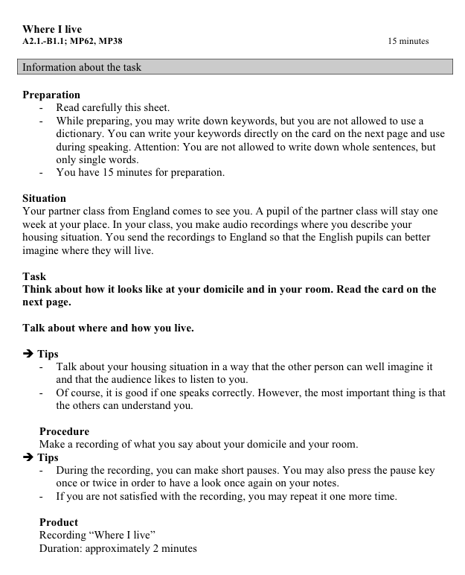

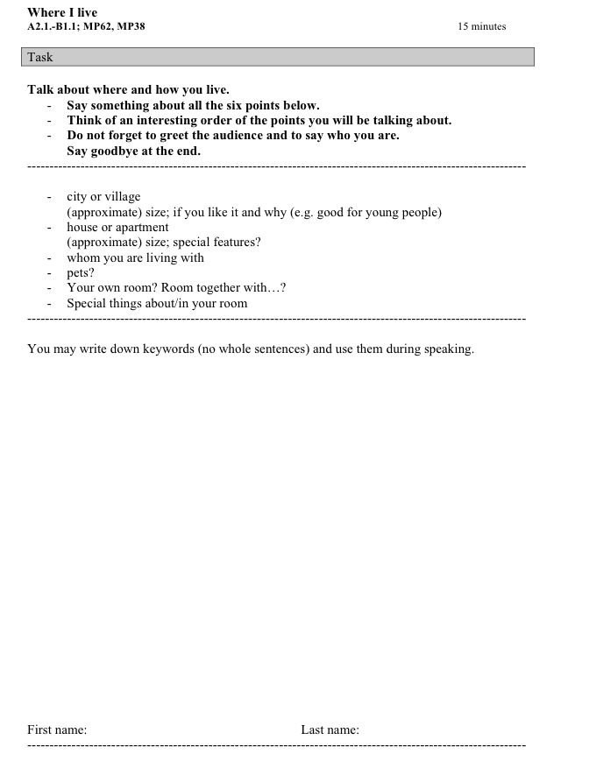

source: *Lingualevel, Instrumente zur Evaluation von Fremdsprachenkompetenzen  
 5. - 9. Schuljahr*. Bern: Schulverlag Plus, 2009 (translation by the authors)

Example 2

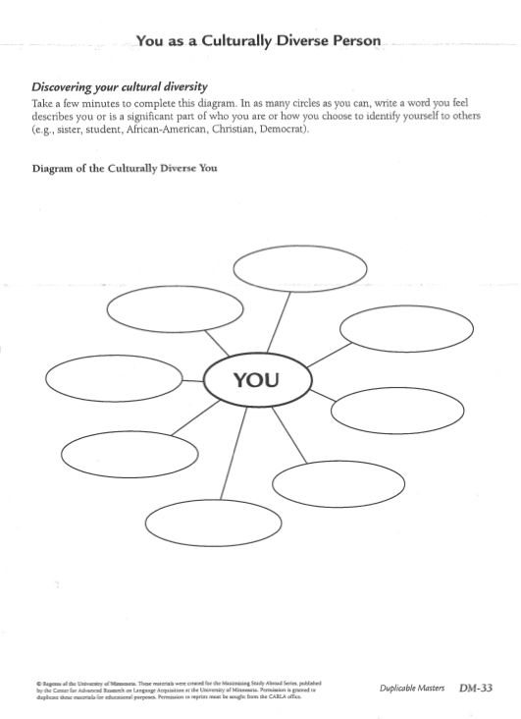

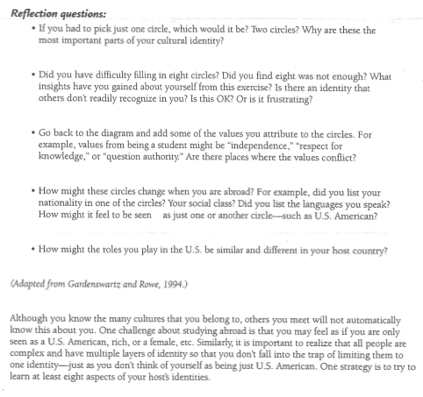

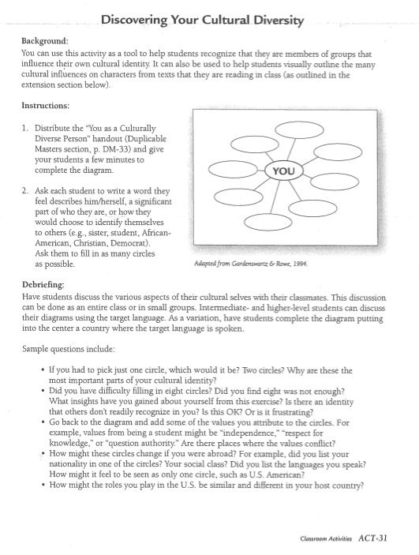

source: Paige, M. R./Cohen, A. D. et al. *Maximizing Study Abroad. A Students’ Guide to Strategies for Language and Culture Learning and Use*. Minneapolis: Board of Regents University of Minnesota, 2006.

# Lesson plan 4 My Autobiography of Intercultural Encounters

**In this lesson plan the learners anticipate and reflect on intercultural encounters during their mobility activity.**

# EXPERIENCES

Learners

* relate their experiences of other cultures and reflect on their reaction
* become aware of the risks of stereotypical thinking
* recognise strategies of successful intercultural communication

# TARGETED COMPETENCES

Learners

* can identify specific forms of behaviour linked to cultural differences (FREPA, skills, S-2.10)
* can talk about/explain certain aspects of their language/culture/other languages/cultures (FREPA, skills, S-4)
* can understand what unites and or what separates people from different cultures (ICCinTE, p. 13)
* can act in situations of contact between languages/cultures (FREPA, skills, S-6)
* can deal with culture clashes and culture shock (ICCinTE, p. 13)
* can gain from previous intercultural experiences to enrich their intercultural competences (FREPA, skills, S-7.3.1)

# PROCEDURE

BEFORE

|  |  |
| --- | --- |
| plurimobil-icon-reflexioncid:EBD7C21A-D5A7-4687-94E6-B75088DA6550@public.local | Teacher invites learners to reflect on their experiences with people from other cultural backgrounds by sharing their own story of an intercultural encounter. The teacher describes his/her own experience in terms of its uniqueness, and also the feelings, thoughts and reactions of all parties involved (e.g. Danish/Polish people putting ketchup on the pizza, see example section).  One or two learners are invited to comment on similar experiences. |
| cid:3C9D767D-834D-4E2F-BB2A-73162838E601@public.localplurimobil-icon-reflexion  cid:3A426EED-C78F-4993-8D6A-CE4E72B5ECB6@public.local | Teacher provides each learner with a questionnaire based on the *Autobiography of Intercultural Encounters*. (As regards experiences teachers could focus on one topic such as: food, dress, music or behaviour in public).  In pairs, learners interview each other about their experience of other cultures and describe their reaction to the selected aspect of the intercultural encounter. The learners write down their experiences. |
| cid:38A387CD-C8EB-439D-98F2-CA5C5F819AFE@public.localcid:13D40CFA-260B-4CF2-AC03-EEB473E52988@public.local | Learners present each other’s stories in a feedback session. Teacher encourages learners to think and define what factors determined their encounters to be successful. He/she makes a list of the strategies learners put forward. Teacher also points out the cases of evident cultural clash and elicits from learner’s ways of avoiding or coping with such a problematic situation. He/she makes a list of the strategies and solutions learners offer. |
| cid:3A426EED-C78F-4993-8D6A-CE4E72B5ECB6@public.localcid:3C9D767D-834D-4E2F-BB2A-73162838E601@public.local | In pairs, learners create a “List of Key Skills of Intercultural Communication”. This list contains ideas of effective ways of communicating and interacting in a culturally varied environment. |

DURING

|  |  |
| --- | --- |
| cid:D0EA8394-2BC7-4AAC-918F-EB51B6EF78E3@public.localcid:06492D4D-A304-4FB7-A674-536E2CD2AD44@public.local | Learners take note of examples of successful intercultural encounters as well as of any culture clashes they experienced during their mobility activity. They also observe whether the “List of Key Skills of Intercultural Communication” created in the classroom is useful. |

AFTER

|  |  |
| --- | --- |
| cid:38A387CD-C8EB-439D-98F2-CA5C5F819AFE@public.localplurimobil-icon-reflexion | Learners review their own “List of Key Skills of Intercultural Communication” after their mobility activity. They recall situations where they used the strategies listed in the list. They also describe and analyse the situations where the recommended strategies failed to work. |

# FINAL PRODUCT FOR THE PORTFOLIO

* completed questionnaires based on the Autobiography of Intercultural Encounters
* list of Key Skills of Intercultural Communication

# TOOLS AND RESOURCES

*Autobiography of intercultural encounters (AIE)*. Council of Europe, 2009.

<http://www.coe.int/t/dg4/autobiography/AutobiographyTool_en.asp>

<http://coe.dokeos.com/courses/AUTOBIOGRAPHYOFINTER/index.php> (AIE Tutorial)

Example

Example of a filled in Autobiography of Intercultural Encounters

(This is only a selection of possible entries in the questionnaire. Feel free to modify the questionnaire; you can use the *Autobiography of Intercultural Encounters* as a point of reference*.*)

Sources:

The questions are taken from the official *Autobiography of Intercultural Encounters* (Council of Europe).

The answers, written by a Tamil student attending a Swiss secondary school, are translated from German and quoted from Z’Graggen, M. *Jugendliche erleben Mobilität im virtuellen Austausch*. St. Gallen: Pädagogische Hochschule St. Gallen (unpublished master thesis), 2012.

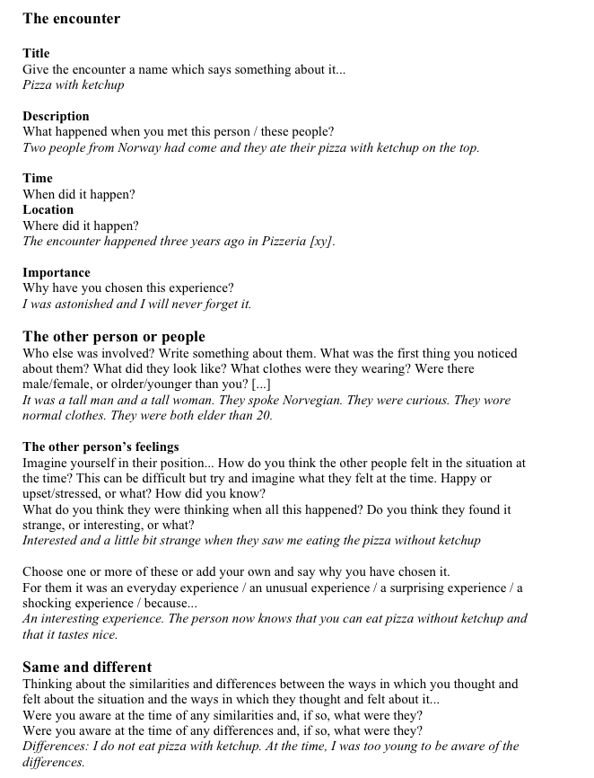

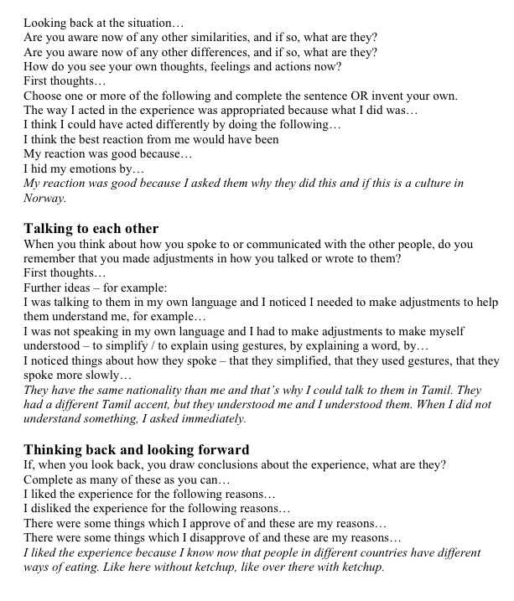

# Lesson plan 5 My topic of Interest in the other culture

**In this lesson plan the learners prepare and conduct an interview on their favorite topics with their host partner, and consciously apply communication strategies.**

# EXPERIENCES

Learners

* imagine themselves already on the mobility activity by reflecting on the areas to observe
* acquire cultural knowledge and greater awareness of their own culture and compare specific cultural elements with the elements of their own culture
* can apply some communication strategies

# TARGETED COMPETENCES

Learners

* develop a system of interpretation which enables them to perceive the particular characteristic of a culture (FREPA, skills, S-1.10)
* can perceive differences or similarities in different aspects of social life (FREPA, skills, S-3.10.2)
* can compare different cultural practices (FREPA, skills, S-3.10.4)
* can communicate in bi/pluringual groups taking into account the repertoire of their interlocutors (FREPA, skills, S-6.1)

# PROCEDURE

BEFORE

|  |  |
| --- | --- |
| cid:3A426EED-C78F-4993-8D6A-CE4E72B5ECB6@public.localcid:13D40CFA-260B-4CF2-AC03-EEB473E52988@public.local | In groups, learners list the areas of their host’s culture which they are interested in and would like to learn more about. Teacher provides an example of an area that could be explored while on mobility and suggests elements to observe. |
| cid:3A426EED-C78F-4993-8D6A-CE4E72B5ECB6@public.localcid:3C9D767D-834D-4E2F-BB2A-73162838E601@public.local | In pairs or small groups, learners design a questionnaire/grid featuring the chosen topic they will complete during their mobility. |
| cid:3A426EED-C78F-4993-8D6A-CE4E72B5ECB6@public.localcid:47C35458-5156-4C6A-80A0-D239B9AB9663@public.local | In pairs the learners interview each other about the other's preferred subject. A dictionary or electronic device can be used for preparation and support.  The students think of possible difficulties when they will interview the partners during the mobility activity. They come up with possible strategies that could be used to overcome difficulties. The possibilities of using one's own language or other languages than the one(s) of the host country/region are discussed (see example section). |
| cid:2355B4C7-5EA0-43EF-BD73-0BD8B3F79998@public.localcid:3C9D767D-834D-4E2F-BB2A-73162838E601@public.local | The teacher can provide a list of possible strategies and discuss them with the learners to see if they already use some of them, in case they think they might be useful, etc. (see example 2). The learners write down what they think to be the three most useful strategies. |

DURING

|  |  |
| --- | --- |
| cid:47C35458-5156-4C6A-80A0-D239B9AB9663@public.localcid:3C9D767D-834D-4E2F-BB2A-73162838E601@public.local | During the mobility, learners interview their hosts and complete the questionnaire/s.  They try to use the strategies they have written down and which they reflected upon earlier. |

AFTER

|  |  |
| --- | --- |
| cid:B1BB973D-94C9-4726-81AB-89A4E0A1CF84@public.local | Learners present the outcome of their survey after the mobility and compare the results with the trends existing in their own environment. |
| cid:3A426EED-C78F-4993-8D6A-CE4E72B5ECB6@public.localcid:1E266292-CC5F-4834-B210-BEFA95E95071@public.local | Learners discuss the strategies (also those implying the use of more than one language) they have used to see which ones proved useful. |

# FINAL PRODUCT FOR THE PORTFOLIO

* completed questionnaires featuring various lifestyles, habits and customs
* list of useful strategies

# TOOLS AND RESOURCES

*Helping Learners learn: exploring strategy instructions in language classroom across Europe*. Council of Europe, Vee Harris, 2001.

Example 1

Sample topics and questions

**List of possible topics**

* music
* food/meals
* home
* sports
* school
* shopping
* going out
* holidays
* free time
* culture (museums, theatre, opera, …)
* nature
* family
* icons, symbols
* telephone – mobile
* computers
* reading
* festivals
* sightseeing

**Example of possible questions about some topics**

**Music**

* Do you play a musical instrument? Did you learn to play a musical instrument at school?
* Do you sing? Did you learn to sing at school?
* Do you know some traditional songs from your country? Can you sing any?
* Do you dance to traditional music in your country/area? Can you dance?
* Did you have music lessons at primary school? What did you play?
* Did you have music lessons at secondary school? What did you play?
* Did you go to a music academy in your free time? What did you learn?
* Do a lot of children go to a music academy in your country/area?
* Do a lot of adults go to a music academy in your country/area?
* Do you sing in a choir?
* Do a lot of children sing in a choir in your country/area?
* Do a lot of adults sing in a choir in your country/area?
* Do you often listen to music? When (in the car, on public transport, while working, while doing household tasks, just for the pleasure)?
* When you celebrate a birthday party, do you sing? What do you sing?
* For Christmas, do you sing? What do you sing?
* Is there any special occasion in your country/area when people meet and sing together? Describe.
* Do you often go to concerts?
* Did you go to concerts with your school?
* Have you ever sung/played in a concert?
* Who is your favourite singer/band?
* Do you download a lot of music?
* Do you listen to music in English, in your mother tongue, in another language?
* Do you want to understand the lyrics of a song?
* Are there some famous singers/bands in your country/area?
* Etc.

**Food**

* every day
* special days
* traditional food
* importance of diet
* importance of organic food
* snacks
* importance of one single food e.g. bread
* home-made, take away, ready-made
* international food

**Meals**

* where?
* when?
* with whom?
* what?
* etc.

**Your home**

* size
* use of the different rooms (what do you do where?)
* material used
* private vs. public space
* domestic duties (who does what, when, how often, …?)
* television viewing habits (who, what, when, choice, where, how often, …?)
* etc.

**Sports**

* everyday conversations
* news
* watching vs. practising
* fan clubs
* etc.

Example 2

Strategies for oral communication

**Strategies using the language of the host of mobility partner**

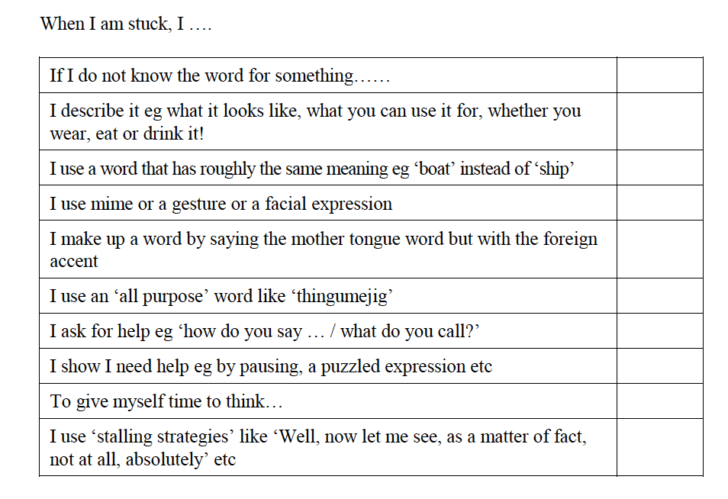

source:

*Helping Learners learn: exploring strategy instructions in language classroom across Europe*. Council of Europe, 2001, p. 182.

**Strategies using more than one language at the same time**

When I am stuck, I ...

|  |  |
| --- | --- |
| I change to my first language or another language and borrow a word or an expression from that language. |  |
| I pronounce a word coming from another language with the accent of the language of my partner. |  |
| I pay attention to how my partner reacts when I use words or expressions from another language. |  |
| I ask if my partner knows that word or expression and how it is said in his or her language. |  |

# Lesson plan 6 Presentation

**In this lesson plan the students prepare and share a presentation on a cultural topic which is personally relevant to them and which will spark the curiosity of their host partners.**

We recommend these tasks in the case of a mobility project which forms part of a broader project involving educational activities focusing on specific themes and issues (example: Comenius Project). In the frequent case of learner/class exchange, the activities should be conducted by learners and teachers from all participating institutions. Teachers may introduce the subject and assign further research during lessons or extra-curricular activities (example: Comenius Club).

# EXPERIENCES

Learners

* reflect on aspects such as the country they live in, their lifestyles, their values and traditions and become more aware of the cultural setting they are part of
* become curious and aware of other culturally determined values, behaviour and ways of thinking
* develop their ability to research information and make the most of the resources available
* develop the necessary linguistic and presentation skills to deliver an interesting and engaging performance in a foreign language

# TARGETED COMPETENCES

Learners

* can better understand their own cultural identity and how it is formed (ICCinTE, p. 13)
* can construct explanations meant for a foreign interlocutor about a feature of their own culture (FREPA, skills, S-4.1)
* can produce simple connected text on topics which are familiar or of personal interest (CEFR, B1)
* can understand the main points of clear standard input on familiar matters regularly encountered in work, school, leisure, etc. (CEFR, B1)
* can present a commentary/exposé in one language based on a plurilingual set of documents (FREPA, skills, S-6.4.1.1)

# PROCEDURE

The subject areas to be explored and presented may include the learners’ country (its national heritage, traditions, customs, tourist sites, cuisine, famous people, education system), ways of spending free time, the cultural and entertainment agenda among others. The activities may also address current trends or problems affecting young people and other groups within the local and international society.

The presentation may also feature the topics listed in lesson plan 6 (My topic of interest in the other culture).

BEFORE

|  |  |
| --- | --- |
| cid:3C9D767D-834D-4E2F-BB2A-73162838E601@public.localcid:D0EA8394-2BC7-4AAC-918F-EB51B6EF78E3@public.local | Learners work individually/in pairs/in teams to generate relevant information, interpret and formulate it in the language of communication. They deliver regular reports on their progress. |
| cid:3A426EED-C78F-4993-8D6A-CE4E72B5ECB6@public.localcid:A0C2536F-432F-4C94-9775-C8B24201B8F0@public.local | Learners may choose to include in their presentations a variety of multimedia materials and additional activities such as poster presentations, quizzes and games. |

DURING

|  |  |
| --- | --- |
| cid:B1BB973D-94C9-4726-81AB-89A4E0A1CF84@public.localcid:06492D4D-A304-4FB7-A674-536E2CD2AD44@public.localcid:3C9D767D-834D-4E2F-BB2A-73162838E601@public.localcid:EBD7C21A-D5A7-4687-94E6-B75088DA6550@public.local | Learners deliver their presentations during the beginning of their visit to their partner school.  Learners take notes about the other presentations (some keywords). They may also take pictures or collect documents. |
| cid:A0C2536F-432F-4C94-9775-C8B24201B8F0@public.local | Suggestion: all presentations can be put on a blog, so that learners still have access to them when they are back at home. |

AFTER

|  |  |
| --- | --- |
| cid:B1BB973D-94C9-4726-81AB-89A4E0A1CF84@public.local | Learners present what they have learnt from their mobility activity, to others who have not taken part in the project. They use the keywords, pictures and documents which they have brought back (multimedia presentations, quizzes and games featuring selected topics and issues). |

# FINAL PRODUCT FOR THE PORTFOLIO

* shared blog
* documentation and/or video of the presentation

Examples

Sample topics of projects

A project about festivals in different countries: What? Where? Origin? When? How long? For whom (children, adults, everybody)? Specialities (drinks, food)?

A project about food: What? Ingredients? Recipes? Origin?

A project about recycling waste: Policy in the school? Habits at home? Rules? Selecting waste: how? Getting rid of waste: how?

A project about music: At school? In academies? What kind of music? Choirs? Orchestras? Bands? National well-known musicians, singers?

# Lesson plan 7 Treasures from abroad

**In this lesson plan learners are encouraged to look out for any interesting during their mobility activity and to select something to bring back home, to present to others.**

# EXPERIENCES

Learners

* open themselves up to perceiving other cultures through objects
* imagine the use and significance of presented items in a chosen cultural setting

# TARGETED COMPETENCES

Learners

* can compare cultural features from different cultures (FREPA, skills, S-3)
* can talk about certain aspects of other cultures (FREPA, skills, S-4)

# PROCEDURE

BEFORE

|  |  |
| --- | --- |
| cid:06492D4D-A304-4FB7-A674-536E2CD2AD44@public.localcid:13D40CFA-260B-4CF2-AC03-EEB473E52988@public.local | Teacher brings an object into class which he/she has brought home from his/her last holiday or even a photo of an object. It may not be immediately clear what the object is and what it is used for. Learners are invited to speculate and solve the mystery (They finally guess – e.g. a musical instrument: A ‘rain stick’ – an instrument that imitates the sound of water). |
| cid:3C9D767D-834D-4E2F-BB2A-73162838E601@public.localcid:06492D4D-A304-4FB7-A674-536E2CD2AD44@public.localcid:47C35458-5156-4C6A-80A0-D239B9AB9663@public.localcid:13D40CFA-260B-4CF2-AC03-EEB473E52988@public.local | Learners bring in objects or photos that are presented in an exhibition to the class. Every learner writes his/her idea of what it could be and where it could come from on a slip of paper which is then collected. In a common discussion, the hypotheses and solutions are presented.  Other persons (e.g. parents, other teachers, other classes) can be invited to look at this exhibition. |

DURING

|  |  |
| --- | --- |
| cid:06492D4D-A304-4FB7-A674-536E2CD2AD44@public.localplurimobil-icon-reflexion | Observing: During their visit, learners are encouraged to look out for any striking objects or gadgets they would not find in their own environment. They should concentrate on unknown, unexpected or special objects and gadgets. Either they bring back the object/gadget or they take a photo of it.  During the mobility activity, they may also discover how familiar objects are used in different contexts. If possible, learners take a photo, too, and bring it back to their class. |

AFTER

|  |  |
| --- | --- |
| cid:B1BB973D-94C9-4726-81AB-89A4E0A1CF84@public.local | Presentation: Learners present their enigmatic ‘souvenirs’ after the mobility, if possible to a wider audience (e.g. learners from other classes, parents, school administration etc.). They tell the audience where the object is from, what it is made of, why they chose it etc. |

# FINAL PRODUCT FOR THE PORTFOLIO

A selection of objects to illustrate new cultural dimensions

Examples of treasures

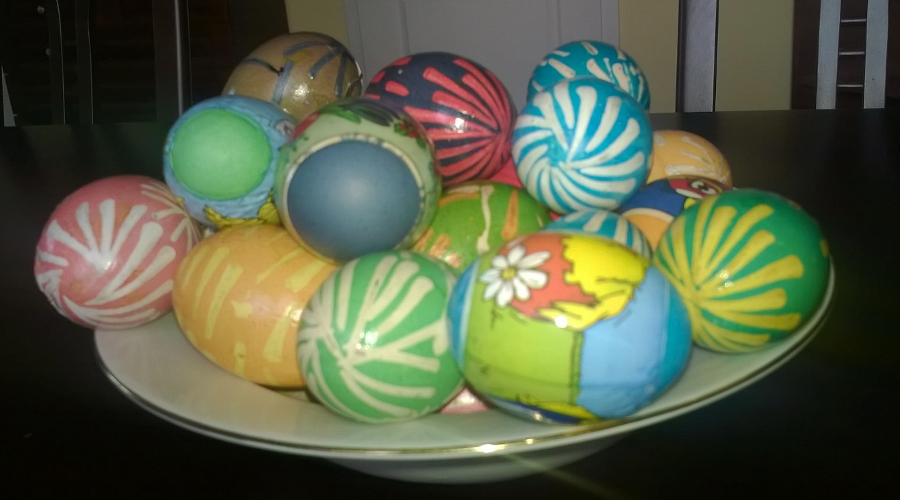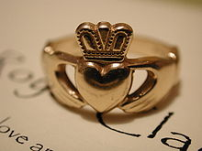

A claddagh ring   
[source of the picture: http://en.wikipedia.org/wiki/Claddagh_ring]

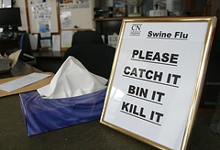

A shop in Whitehaven, Cumbria, UK helps fight the swine flu pandemic in June 2009.   
[Source of the picture: [Alan Cleaver](https://www.flickr.com/photos/alancleaver/): https://www.flickr.com/photos/alancleaver/4055990073/in/photostream/]

Pisanki (Polish) – eggs painted at Easter time  
(for details see e.g. http://en.wikipedia.org/wiki/Pisanka_%28Polish%29)

[Picture: ©Anna Michońska-Stadnik]

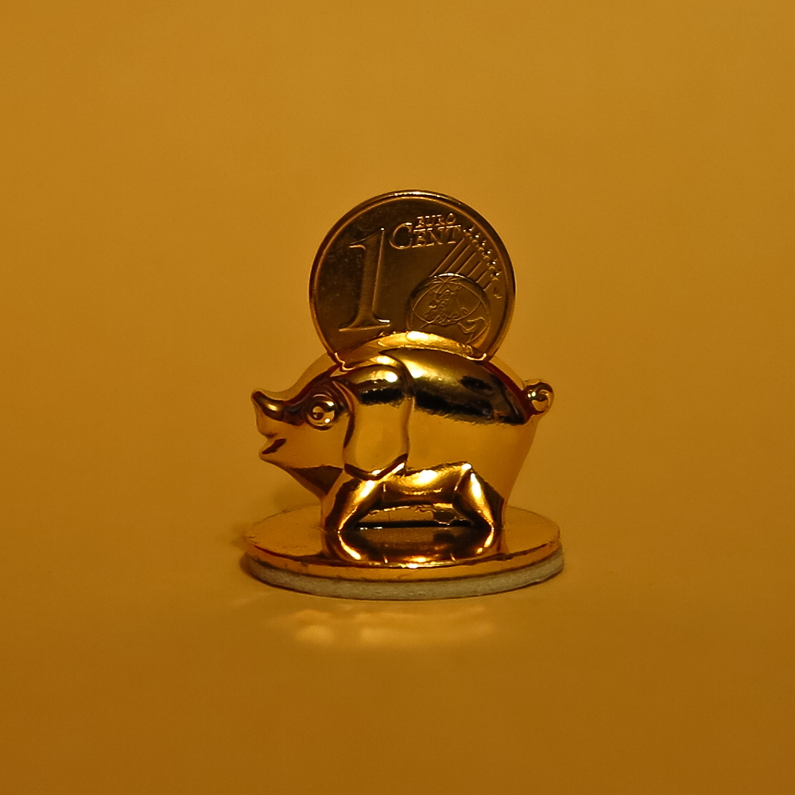

Glücksschwein – a luck bringer, mainly in German-speaking countries

[source of the picture: http://fc-foto.de/27278142]

# Lesson plan 8 Appetite for culture

**In this lesson plan the learners become aware of similarities, differences, and diversity in eating habits and foods.**

# EXPERIENCES

Learners

* reflect on their local culture by looking at eating habits
* become aware of similarities and differences in eating habits and foods, table manners, staple food, and learn how to cope with difference through taste
* develop and use the linguistic instruments to communicate in the host country (the language of communication is a foreign language for all institutions)
* talk and reflect on the host country’s cultures (socio-cultural contexts within eating habits)
* develop the ability to present and transfer the knowledge and skills gained during the mobility activity

# TARGETED COMPETENCES

Learners

* can better understand their own cultural identity and how it is formed (ICCinTE, p. 13)
* can understand what unites or separates people from different cultures (ICCinTE, p. 13)
* can observe/analyse linguistic/cultural phenomena in languages/cultures which are more or less familiar (FREPA, skills, S-1)
* can communicate in bi/plurilingual groups taking into account the repertoire of their interlocutors (FREPA, skills, S-6.1)
* can benefit from previous learning experiences in new situations (FREPA, skills, S-7.7.3.1)

# PROCEDURE

BEFORE

|  |  |
| --- | --- |
| cid:D0EA8394-2BC7-4AAC-918F-EB51B6EF78E3@public.localcid:3C9D767D-834D-4E2F-BB2A-73162838E601@public.local | Learners create a questionnaire in the language of communication with closed/open questions on meals, type/duration of meals, staple food, participating members etc. The survey may include some of the questions listed on page 20 ff. of the ECML publication *Mirrors and Windows (see below "tools and resources”).* |
| cid:2355B4C7-5EA0-43EF-BD73-0BD8B3F79998@public.localcid:A0C2536F-432F-4C94-9775-C8B24201B8F0@public.local | Exchange: Learners distribute their questionnaire to the whole class. Reading the others’ answers to the questionnaire, they collect information and find out similarities and differences. |
| cid:D0EA8394-2BC7-4AAC-918F-EB51B6EF78E3@public.localcid:3C9D767D-834D-4E2F-BB2A-73162838E601@public.local | Individual work: Learners create a poster in the language of communication. |
| cid:B1BB973D-94C9-4726-81AB-89A4E0A1CF84@public.localcid:38A387CD-C8EB-439D-98F2-CA5C5F819AFE@public.local | Learners present their poster in class and discuss the most (un)usual personal habits. The attention of the learners must also be drawn to the diversity and changing nature of food habits within a same area/culture. |

DURING

|  |  |
| --- | --- |
| cid:B1BB973D-94C9-4726-81AB-89A4E0A1CF84@public.local | During the mobility activity, learners present the poster in the language of communication to the host institution and other partners. |

Further suggestion for activities and methods:

|  |  |
| --- | --- |
|  | **Eating together** (project suggestion in *Mirrors and Windows*). The teacher may introduce the story ‘What time is lunch at?’ on pages 20-21 to encourage the learners to observe any new cultural specificities connected with food and eating.  The questions to be addressed may include:  (At the restaurant/canteen/home)  *How do/did you cope with ordering your food?*  *What strikes you the most?*  *How do/did you like the food?*  At the end of the stay they share impressions on eating together.  These questionnaires/projects may be presented by learners after the mobility in their own institution. |

AFTER

Learners share the learning experiences they had during their mobility activity by:

|  |  |
| --- | --- |
| cid:47C35458-5156-4C6A-80A0-D239B9AB9663@public.localcid:38A387CD-C8EB-439D-98F2-CA5C5F819AFE@public.local | bringing back traditional ingredients from the host country as well as the recipe of a traditional dish to share with the class (project suggestion in *Mirrors and Windows*, p. 25 TN 2.7.) |
| cid:A0C2536F-432F-4C94-9775-C8B24201B8F0@public.local | presenting the experience gained via Power-point presentation (recorded clips of tasting the staple foods in the host country/region, diversity of eating habits observed, main dishes, pictures of the ingredients and preparation stages of a chosen traditional dish) |
|  | conducting language lessons featuring idioms involving food in the language of communication, the language of the host country/region and their own language activity on pages 26-28 in *Mirrors and Windows* |
|  | sharing the prepared dish with classmates, encouraging comments and discussion on similarities and differences with dishes from their culture(s) |

# FINAL PRODUCT FOR THE PORTFOLIO

Before phase

* questionnaires on eating habits and rituals
* presentations on eating habits and rituals

During phase

* questionnaire on the first encounter
* questionnaire/project on food and eating in the host country

After phase

* presentations featuring food and eating in a foreign country
* list of ‘food’ idioms in two (or more) languages

# TOOLS AND RESOURCES

*Mirrors and Windows – An Intercultural Communication Textbook*. Council of Europe, 2003, chapter 2: *You are what you eat*

# Lesson plan 9 The European Language Portfolio: How do I learn and how do I want to learn?

**In this lesson plan learners set themselves goals for language learning during their mobility activity, think about their learning strategies and also assess their personal progress.**

This activity can be conducted by learners from all institutions participating in the mobility project. Selected material from the European Language Portfolio (which in different countries varies in its contents, see introduction to PluriMobil) can be used to draft a common questionnaire in the target language for all institutions involved. These individual progress records can later be compared between institutions once the mobility activities are completed.

# EXPERIENCES

Learners

* reflect on their language learning strategies and formulate objectives to be achieved during the mobility activity as well as in the near future
* identify the methods which enable their progress in language acquisition
* plan their own work
* assess their progress in the target language by using the European Language Portfolio (ELP)

# TARGETED COMPETENCES

Learners

* can learn autonomously (FREPA, skills, S-7.6)
* can organise learning in an autonomous way
* can use resources to facilitate language learning
* can use linguistic reference tools
* can use the help of others in order to learn
* can reflect on learning processes in order to make them more effective (FREPA, skills, S-7.7)
* can define their own learning needs/learning objectives (FREPA, skills, S-7.7.1)
* can observe and check their own approaches to learning (FREPA, skills, S-7.7.4)

# PROCEDURE

BEFORE

|  |  |
| --- | --- |
| cid:D0EA8394-2BC7-4AAC-918F-EB51B6EF78E3@public.localcid:3C9D767D-834D-4E2F-BB2A-73162838E601@public.local | The teacher encourages learners to use the European Language Portfolio (ELP) or the grid attached to this lesson plan (Example 1 – Learning strategies) to reflect on their language learning strategies. Then individually, learners mark relevant items regarding things they do to learn the language (the first column in the grid). If the teacher wishes, the learners can concentrate just on selected categories (e.g. ‘I listen to’ and ‘I watch’ only) and come back to the rest of the categories next time. |
| cid:3A426EED-C78F-4993-8D6A-CE4E72B5ECB6@public.localcid:47C35458-5156-4C6A-80A0-D239B9AB9663@public.local | Learners talk in pairs. They compare and discuss what they do to learn the language. They describe their techniques to each other and think about the possible advantages of them. |

The teacher uses a self-assessment checklist from the ELP or alternatively the checklist provided in Example 2 below (A2 level of competence).

|  |  |
| --- | --- |
| cid:D0EA8394-2BC7-4AAC-918F-EB51B6EF78E3@public.localplurimobil-icon-reflexion | Learners assess their language competence by working off the checklists of the ELP. They reflect on what they can do and what they need to practice. They are also invited to think about the most effective ways they learn a language (language learning strategies). With this knowledge, they can formulate their learning objectives more efficiently (they will return to the goals they have set, and reflect on them once the mobility activity is completed). |

DURING

|  |  |
| --- | --- |
| cid:D0EA8394-2BC7-4AAC-918F-EB51B6EF78E3@public.localplurimobil-icon-reflexion | Learners observe their progress and use of language learning strategies and complete the self-assessment checklist (Example 2) |

AFTER

|  |  |
| --- | --- |
| cid:D0EA8394-2BC7-4AAC-918F-EB51B6EF78E3@public.localplurimobil-icon-reflexion | Learners individually can update their checklist and decide whether they have managed to achieve their learning goals. |
| cid:3A426EED-C78F-4993-8D6A-CE4E72B5ECB6@public.localplurimobil-icon-reflexion | Then in pairs or in groups, learners discuss whether they have achieved their goals or not. They are asked to describe what they benefited from implementing new techniques and to think if the new strategies they implemented were helpful. |

# FINAL PRODUCT FOR THE PORTFOLIO

Before phase

* a written record of the list of language learning strategies used by learners
* a record of goals: the list of language learning strategies that learners would like to implement and work on.

After phase

* the list of language learning strategies used by learners
* an account of how the goals were accomplished.

# TOOLS AND RESOURCES

Głowacka, B. *Czego Janek się nauczy… – the guidebook for teachers to the ELP for 10-15 years old students (the Polish version)*. Warszawa: CODN, 2004.

European Language Portfolio (ELP for 10-15 year-old students – translation and illustrations from the Polish version). Warszawa: CODN : p. 12-13, 2004.

The original *European Language Portfolio* is the English version edited by the Council of Europe.

*European Language Portfolio* Website of the Council of Europe: <http://www.coe.int/t/dg4/education/elp/>

Example 1

Learning strategies

**How do I learn languages?**

Mark [**√**] in the first column to show what you do to learn a foreign language. In the second column mark those techniques you would like to use in the future. You can add your own ideas.

|  |  |  |  |  |
| --- | --- | --- | --- | --- |
|  | **In the language I am learning** | **I do the following** | **I would like to learn like this** |  |
| **I listen to** | songs on the radio, TV | [] | [] |
| recorded lessons on tapes and CDs | [] | [] |
| radio and TV news | [] | [] |
| ... | [] | [] |
| **I watch** | films on TV, in the cinema, on video/DVD | [] | [] |
| other TV programs | [] | [] |
| ... | [] | [] |
| **I read** | texts from the course book | [] | [] |
| comic strips | [] | [] |
| websites | [] | [] |
| magazines for teenagers | [] | [] |
| books (e.g. simplified versions) | [] | [] |
| ... | [] | [] |
| **I write down** | words of wisdom | [] | [] |
| lyrics | [] | [] |
| new vocabulary and expressions | [] | [] |
| my observations, conclusions, comments | [] | [] |  |
| ... | [] | [] |
| **I write** | notes | [] | [] |
| compositions | [] | [] |
| postcards, letters, e-mails to my peers from other countries | [] | [] |
| ... | [] | [] |
| **I check** | the answers to the exercises in the answer key | [] | [] |
| the meaning of the new words in a dictionary | [] | [] |
| the irregular forms of needed words in grammatical tables | [] | [] |
| ... | [] | [] |
| **I translate** | short texts (e.g. lyrics, advertisements, captions of photos) | [] | [] |
| ... | [] | [] |
| **I keep** | tests and compositions with positive marks | [] | [] |
| other interesting works | [] | [] |
| ... | [] | [] |
| **I try to** | do my homework on my own | [] | [] |
| participate in lessons | [] | [] |
| regularly listen to the recordings in the language I am learning | [] | [] |
| learn together with my friends | [] | [] |
| participate in extra classes of the language I am learning | [] | [] |
| ... | [] | [] |  |

[Source: European Language Portfolio (ELP for 10-15 year-old students – translation and illustrations from the Polish version). Warszawa: CODN : p. 12-13, 2004]

Example 2

Goal setting checklist (A2)

**Have a look at the table:**   
**Before** your mobility activity, list some language goals you’d like to achieve. Think about what you can do to achieve these goals.   
**During** your mobility activity, check if you are really doing what you have planned to do.   
**After** your mobility activity, tick the goals you have actually achieved.

|  |  |  |  |
| --- | --- | --- | --- |
| Goals | BEFORE  What can I do during my mobility stay to achieve these goals? Explain | DURING  What am I actually doing? Explain | AFTER  Have I reached my goal? Please tick if yes. |
| LISTENING |  |  |  |
| I can understand the main point in short and very simple TV news, if I can see pictures. |  |  |  |
| I can understand what the topic is if people speak slowly and clearly |  |  |  |
|  |  |  |  |
| READING |  |  |  |
| I can understand simple descriptions of people, things and places |  |  |  |
| I can understand simple instructions, e.g. in a lift, on a public telephone or in a computer programme if there are also symbols or pictures |  |  |  |
|  |  |  |  |
| SPEAKING |  |  |  |
| I can order something to eat or drink in a simple way, e.g. in a bar |  |  |  |
| I can take part in a very short and simple conversation on a familiar topic, e.g. how we spent our Sunday |  |  |  |
|  |  |  |  |
| WRITING |  |  |  |
| I can describe places, people and things in a simple way |  |  |  |
| I can describe myself and my favourite activities in a simple way, e.g. what I like doing in my free time (my hobby) |  |  |  |
|  |  |  |  |

Based on the self-assessment grid of the Common European Framework of Reference (© Council of Europe)

# Lesson plan 10 The European Language Portfolio: What do I use to learn?

**In this lesson plan the learners reflect on different resources they can use to learn languages.**

# EXPERIENCES

Learners

* identify the methods which enable their progress in language acquisition
* reflect on their language learning strategies and formulate objectives to be achieved during the mobility activity and in the near future
* assess their progress in the area of language acquisition, by using the European Language Portfolio (ELP)

# TARGETED COMPETENCES

Learners

* can learn autonomously (FREPA, skills, S-7.6)
* can organise learning in an autonomous way
* can use resources to facilitate language learning
* can use linguistic reference tools {bilingual dictionaries, grammar summaries...}
* can use the help of others in order to learn
* can reflect on learning processes in order to make them more effective (FREPA, skills, S-7.7)
* can observe and check their own approaches to learning (FREPA, skills, S-7.7.4)

# PROCEDURE

BEFORE

The teacher encourages learners to brainstorm what tools can be used for learning languages.

|  |  |
| --- | --- |
| cid:1E266292-CC5F-4834-B210-BEFA95E95071@public.localcid:38A387CD-C8EB-439D-98F2-CA5C5F819AFE@public.local | Learners are invited to think about the ways they are exposed to new languages (e.g. songs, films, magazines, books, computer games, websites, etc.) and the most effective ways they learn a language (language learning strategies e.g. listening to CDs, reading magazines and simplified books for teenagers, watching films, websites). Learners are invited to give specific examples (e.g. the titles of books and magazines they read, the titles of films, CDs/CD-ROMs, etc.) |
| cid:D0EA8394-2BC7-4AAC-918F-EB51B6EF78E3@public.localcid:3C9D767D-834D-4E2F-BB2A-73162838E601@public.local | Learners work individually. They fill in the questionnaire from the examples section in this lesson plan (European Language Portfolio – Biography – What do I use for learning languages?). |
| cid:38A387CD-C8EB-439D-98F2-CA5C5F819AFE@public.local | The teacher elicits answers from learners in order to discuss what tools for language learning are the most and also the least popular among learners. The teacher may bring and demonstrate different examples of learning resources. |

DURING

|  |  |
| --- | --- |
| cid:D0EA8394-2BC7-4AAC-918F-EB51B6EF78E3@public.localcid:3C9D767D-834D-4E2F-BB2A-73162838E601@public.local | Learners are asked to start a scrapbook which will function as their reference book and help them to assess their learning strategies.  Learners collect every type and piece of evidence which shows their personal language development. They can glue into their scrapbook any article they have read, any label from different types of products, tickets. They can write down the list of expressions they have learnt from favourite songs, films in L2, the conversations they heard, etc. |

AFTER

Teacher asks learners to reflect on their language learning strategies.

|  |  |
| --- | --- |
| cid:3A426EED-C78F-4993-8D6A-CE4E72B5ECB6@public.localplurimobil-icon-reflexion | Learners look at the questionnaire from the example section in this lesson plan (European Language Portfolio – Biography – What do I use for learning languages?). In pairs they compare their development and mark changes, if necessary. They acknowledge their progress. |
| cid:38A387CD-C8EB-439D-98F2-CA5C5F819AFE@public.localplurimobil-icon-reflexion | Learners discuss, in pairs or small groups, different tools and sources to learn languages. Has the mobility experience changed their use of learning resources? They share their experience and discuss possible ways of broadening their repertoire of language materials. |

# FINAL PRODUCT FOR THE PORTFOLIO

Before phase

* a written record of the list of language learning tools used by learners

After phase

* updated record of the list of language learning tools used by learners (the grid attached to this lesson plan)

# TOOLS AND RESOURCES

*European Language Portfolio* (ELP for 10-15 year-old students – translation and illustrations from the Polish version). Warszawa: CODN : p. 11, 2004.

The original *European Language Portfolio* is the English version edited by the Council of Europe.

*European Language Portfolio* Website of the Council of Europe: <http://www.coe.int/t/dg4/education/elp/>

Example

**What do I use for learning languages?**

|  |  |  |  |  |
| --- | --- | --- | --- | --- |
| **Mark [√], to show how often you use the following tools. You can update the list during the learning process!** | | | | |
|  | Often | Rarely | Very rarely | skanowanie0004 |
| **Course books**  e.g. | **[ ]** | **[ ]** | **[ ]** |
| **Dictionaries**  e.g. | **[ ]** | **[ ]** | **[ ]** |
| **Recordings for language learning**  e.g. | **[ ]** | **[ ]** | **[ ]** |
| **Computer programs**  e.g. | **[ ]** | **[ ]** | **[ ]** |
| **Books for language learning**  e.g. | **[ ]** | **[ ]** | **[ ]** |
| **Press for teenagers**  e.g. | **[ ]** | **[ ]** | **[ ]** |
| **Magazines**  e.g. | **[ ]** | **[ ]** | **[ ]** |
| **Comic strips**  e.g. | **[ ]** | **[ ]** | **[ ]** |
| **Films**  e.g. | **[ ]** | **[ ]** | **[ ]** |
| **TV programmes**  e.g. | **[ ]** | **[ ]** | **[ ]** |
| **Websites**  e.g. | **[ ]** | **[ ]** | **[ ]** |
| **Lyrics**  e.g. | **[ ]** | **[ ]** | **[ ]** |
| **Computer games**  e.g. | **[ ]** | **[ ]** | **[ ]** |
| **Board games**  e.g. | **[ ]** | **[ ]** | **[ ]** |
| **Other tools:** | **[ ]** | **[ ]** | **[ ]** |

# Lesson plan 11 My Learning Diary

**In this lesson plan the learners observe their own language learning during their mobility activity, by keeping a diary.**

# EXPERIENCES

Learners

* observe their progress by means of a learning diary
* improve their language skills
* collect and record evidence of linguistic development

# TARGETED COMPETENCES

Learners

* can observe/analyse linguistic elements/cultural phenomena in languages/cultures which are more or less familiar (FREPA, skills, S-1)
* can observe progress/lack of progress in their own learning (FREPA, skills, S-7.7.4.1).

# PROCEDURE

BEFORE

|  |  |
| --- | --- |
| cid:3C9D767D-834D-4E2F-BB2A-73162838E601@public.localcid:38A387CD-C8EB-439D-98F2-CA5C5F819AFE@public.localcid:1E266292-CC5F-4834-B210-BEFA95E95071@public.local | The teacher encourages learners to keep a diary during their mobility activity. It can be in the form of a notebook or a blog. The teacher assists by presenting a list of topics to be explored. They decide together what subject area/s they are going to focus on and give reasons for their choice. The list may include:   * vocabulary – expressions around their hobbies * formal/informal language * idioms/proverbs/connotations * classroom language * false friends * images/signs * advertisements * jokes * language connected with food/sport/transport/sightseeing, etc. * …   Once the topics are selected, learners are encouraged to provide some examples, e.g. found in dictionaries/on the internet. |

DURING

|  |  |
| --- | --- |
| cid:1E266292-CC5F-4834-B210-BEFA95E95071@public.localcid:3C9D767D-834D-4E2F-BB2A-73162838E601@public.local | During the mobility activity, learners seek further examples to complete the diary/blog. They can do it on their own by observing their surroundings. Alternatively, in some cases they can ask their host families or peers from the host institution. |

AFTER

|  |  |
| --- | --- |
| cid:B1BB973D-94C9-4726-81AB-89A4E0A1CF84@public.localcid:38A387CD-C8EB-439D-98F2-CA5C5F819AFE@public.local | Learners present and exchange their findings with their teacher and peers. |

# FINAL PRODUCT FOR THE PORTFOLIO

learning diary

Example

**Sample contents of a learning diary**

|  |  |  |
| --- | --- | --- |
| Subject area/topic | Examples found before the mobility activity | Examples found during the mobility activity |
| Signs | No smoking!  Danger, keep out!  Staff only! | ... |
| False friends | Actually  Pension  Novel | ... |
| Idioms | ‘learn something by heart’  ‘be on cloud nine’ | ... |
| Classroom language | ‘Sit down!’  ‘Open your workbook’  ‘Listen and repeat’ | ... |

# Lesson plan 12 Language hungry!

**In this lesson plan learners revise phrases they might need during their mobility activity.**

# EXPERIENCES

Learners

* develop new linguistic skills, express some basic language functions in different languages
* become curious and enthusiastic about other languages and cultural backgrounds
* apply various elements of the target language

# TARGETED COMPETENCES

Learners

* can ask and answer simple questions in areas of immediate need or on very familiar topic. (CEFR, A1 speaking)
* can activate bilingual or plurilingual communication in relevant situations (FREPA, skills, S-6.5)
* can memorise/reproduce unfamiliar features of a language (FREPA, skills, S-7.1 and S-7.2)

# PROCEDURE

BEFORE

|  |  |
| --- | --- |
| cid:3C9D767D-834D-4E2F-BB2A-73162838E601@public.localcid:1E266292-CC5F-4834-B210-BEFA95E95071@public.localcid:38A387CD-C8EB-439D-98F2-CA5C5F819AFE@public.local | Learners brainstorm about the type of language they might need when on their mobility activity. This can include vocabulary and language structures used in situations relevant to their mobility activity, such as for example: introducing oneself, providing information about oneself, expressing emotions, problems and needs, asking for information and help, expressing gratitude, acceptance, refusal among others in groups they establish a list of priorities.  By doing this they do not only imagine themselves already on the mobility activity and evaluate their language needs, they also learn to see what other people coming to their own country might need. |
| cid:A0C2536F-432F-4C94-9775-C8B24201B8F0@public.local | Learners prepare some material to send to their mobility partners in order for them to learn their language. Learners teach their mother tongue and receive some information and material from other participants about their languages.  The material can include flashcards/drawings, sketches (photographs, text, audio), filmed role plays, tongue twisters, songs, games. |

DURING

|  |  |
| --- | --- |
| cid:47C35458-5156-4C6A-80A0-D239B9AB9663@public.localcid:38A387CD-C8EB-439D-98F2-CA5C5F819AFE@public.local | Learners from all participating institutions form groups. Each group has two learners who take on the role of teachers of the language of their institution.  The ‘learners’ are exposed to selected items of a new language. These can include structures of communication such as introducing oneself or expressing one’s feelings and needs. The items can also include humorous tongue twisters or a song or a game (see examples 1 - 3 in the example section).  Learners are invited to stage the language they have learnt in the form of an interview, a role play or a performance. |

AFTER

|  |  |
| --- | --- |
| cid:13D40CFA-260B-4CF2-AC03-EEB473E52988@public.localcid:38A387CD-C8EB-439D-98F2-CA5C5F819AFE@public.local | Learners are put into groups and they prepare some questions for a quiz for the other groups, about what they have learnt in the different languages they have encountered during their mobility activity.  Learners are encouraged to compare features of the different languages they have encountered:   * new sounds * amount of vowels and consonants used * length of words * similar words * false friends * (grammatical features, e.g. no use of articles, mark of the plural, etc.) |

# FINAL PRODUCT FOR THE PORTFOLIO

list of what they have learnt about other languages – comparisons, melody of the language, some difficult sounds to pronounce, some words they remember, etc.

# TOOLS AND RESOURCES

* flashcards
* tongue twisters
* songs
* games
* etc.

Example 1

**Tongue twisters**

E.g. A proper copper coffee pot

Long legged ladies last longer

Mixed biscuits, mixed biscuits

A box of biscuits, a box of mixed biscuits and a biscuit mixer!

She sells sea-shells on the sea-shore.

Which wristwatches are Swiss wristwatches?

<http://learnenglishkids.britishcouncil.org/fr/tongue-twisters>

<http://www.download-esl.com/tonguetwisters/easy/easytongue.html>

Example 2

**Jazz chants**

These are chants using natural chunks of language on a rhythm. This makes them very memorable and helps integrate the pronunciation and get the melody of the language.

[**https://www.youtube.com/watch?v=R_nPUuPryCs**](https://www.youtube.com/watch?v=R_nPUuPryCs)

[**https://www.youtube.com/watch?v=sotUp32mpOI**](https://www.youtube.com/watch?v=sotUp32mpOI)

[**https://www.youtube.com/watch?v=0bMxj_p7Az4**](https://www.youtube.com/watch?v=0bMxj_p7Az4)

[**https://www.youtube.com/watch?v=hGJEC-__S3k**](https://www.youtube.com/watch?v=hGJEC-__S3k)

**Songs**

Using well-known songs like “Brother John” – The melody might be known in many countries. The text can be adapted to suit a particular situation.

E.g. I like chocolate. I like chocolate.

How about you? How about you?

Do you like chocolate? Do you like chocolate?

Yes, I do! Yes I do! (No, I don’t! No, I don’t!)

It could also be motivating for teenagers to use a song from the charts.

Example 3

**Games**

Memory is a game that most learners would know. The rule is easy to explain. The cards are turned written side down on a table and a learner picks two of them. If they match he gets a point. If they don’t match, he puts them down on the table again. Then it is another learner’s turn. The learner who gets the most points at the end of the game wins.

*Cut on the dotted line. Modify if necessary.*

|  |  |  |  |
| --- | --- | --- | --- |
| **How are you?** | **Fine!** | **Would you like some soup?** | **Yes, please!** |
| **Do you like chocolate ice-cream?** | **Oh, yes, I do** | **Have you got brothers and sisters?** | **Yes, I have one sister and two brothers.** |
| **Where do you live?** | **I live in Abingdon.** | **Is it a big city or a small village?** | **It is a small city.** |
| **What’s your favourite dish?** | **Pizza!** | **Nice to meet you!** | **Nice to meet you!** |
| **Who is your favourite singer/group?** | **Rihanna** |  |  |
|  |  |  |  |

Example 4

**A difficult customer**

Situation: in a clothes shop

Characters:

* a saleswoman
* a difficult customer
* Hi! I would like some black jeans and a red T-shirt.
* Here are two pairs of black jeans and three different red T-shirts.
* Would you like to try them on?
* Yes, of course!
* The fitting room is over there.
* What about the jeans? Do they fit?
* No, they are too long!
* What about the others?
* No, they are too short!
* What about the T-shirts?
* This one is too small!
* What about the other ones?
* This one is too big!
* What about the last one?
* I don’t like this colour red!
* Have you got something else?
* Sorry, I can’t help you. That’s all we have.

The sketch can be acted out and filmed, or made into a photo-novella.

The characters can be changed and other characters can be added, e.g. a 13-year-old girl, her mother, her impatient brother.

# Lesson plan 13 Planning a mobility project as a host

**In this lesson plan the learners decide what they would like to show their mobility partners in their town/area.**

# EXPERIENCES

Learners

* notice that there are different ways of living and different places in which they live or which they know about
* imagine themselves already on the mobility activity
* apply various elements of the target language

# TARGETED COMPETENCES

Learners

* can better understand their own cultural identity (ICCinTE, p. 13)
* can identify cultural specificities (FREPA, skills, S-2)
* can perceive differences and similarities in different aspects of their social life (FREPA, skills, S-3.10.2)
* can compare features of culture (perceive the cultural proximity/distance) (FREPA, skills, S. 3.10)

# PROCEDURE

BEFORE

|  |  |
| --- | --- |
| cid:3A426EED-C78F-4993-8D6A-CE4E72B5ECB6@public.local | The learners discuss in pairs about what they would like to show in their town. |
| cid:38A387CD-C8EB-439D-98F2-CA5C5F819AFE@public.local | Teacher and learners list the different suggestions. Teacher might elicit some more elements that have not come up and which might be interesting. |
| cid:06492D4D-A304-4FB7-A674-536E2CD2AD44@public.local | Alternative: they go together to the place they will visit and try to find out a lot of interesting things about it. They try to find varied things to present to their hosts, things reflecting the different aspects of their home city: important and well-known buildings, industries, markets, different types of housing, etc. |
| cid:A0C2536F-432F-4C94-9775-C8B24201B8F0@public.localcid:3A426EED-C78F-4993-8D6A-CE4E72B5ECB6@public.local | Together the teacher and learners decide on a possible itinerary, not too long, not too short, including some of the interesting elements mentioned earlier. They look for information about the different places to visit. |
| cid:38A387CD-C8EB-439D-98F2-CA5C5F819AFE@public.localcid:3C9D767D-834D-4E2F-BB2A-73162838E601@public.local | They reflect on how they could make the visit more attractive, more enjoyable. They list different ways of doing this:   * treasure hunt * observation tasks * quiz * drawings * asking for/finding out some information * …   They prepare a mini-book with all the tasks to perform which will accompany the partners on the visit. |

DURING

|  |  |
| --- | --- |
| cid:38A387CD-C8EB-439D-98F2-CA5C5F819AFE@public.local | The learners and the host pupils play the treasure hunt, the game. |

AFTER

|  |  |
| --- | --- |
| cid:38A387CD-C8EB-439D-98F2-CA5C5F819AFE@public.localplurimobil-icon-reflexion | The learners reflect on what they have learnt about their home town. |

# FINAL PRODUCT FOR THE PORTFOLIO

* game
* treasure hunt
* quiz

# TOOLS AND RESOURCES

* flashcards
* tongue twisters
* songs
* games

Example

Ideas of games to play on site, in town.

On a square on a piece of paper – each learner draws the shape of a building of his choice. The drawings are mixed up and redistributed. Nobody should receive their own picture. The learners have to find the building drawn.

One learner describes the drawing he has received; the others have to find out which one it is.

One learner has got a drawing/a photograph. The others ask yes/no questions to guess what building it is. The learner can say that he doesn’t know.

Learners are put into groups. A nearby colour (e.g. of a building) is chosen by each group. Group 1 must say something about the colour they can see from where they are standing. Then it’s the turn of group 2, etc. until every group has had a go. If the building or object whose colour has been chosen by the group, cannot be identified, this group is the winner.

-> Instead of choosing, they can also choose a material: metal, bricks, glass, stone, concrete.

**Making a time line**

The learners choose/make a series of pictures/photographs (e.g. of buildings and other objects). They find out about the time period of creation of a building or an object. The host pupils must organize these pictures in a time line. They receive the pictures before the visit and can ask questions along the way in order to complete their task.

**Situating in time**

The learners choose/make a series of pictures. They find out about the time period of creation of a building or an object.

**20th – 21st century or not?**

The host pupils must find out which pictures belong to the 20th or 21st centuries and which refer to things which are older.

Which time period? Anglo-Saxon England? Medieval England? Tudors? Georgian times? Victorian time? 20th century? 21st century?

The host pupils must put the pictures they have received in order, according to their date of creation.

**Different cultures**

In groups, learners make pictures of different things referring to different regions. They should try to find and present as many different regions as possible.